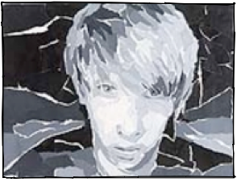
Shape Unit
Visual Problem 4:
Chiaroscuro Self-Portrait
For the final visual problem of our shape unit we are going to create a self-portrait using torn grayscale paper. Using torn paper instead of direct drawing/painting requires you to visually divide the grey areas into separate shapes and define each shape individually. You will work directly on a piece of lamination over the image, eliminating the need for preliminary sketches and keeping the image constantly in front of you so you can "copy" the values. Your likeness will be digitally photographed in class (you can opt to bring in a printed, full page, grayscale photo from home) and printed in grayscale on an 8.5"x 11" paper. You will have to really look and perceive the placement of features, facial planes, shadows and highlights for this to come out nicely.
- EXPRESSIVE Self-Portraits will be photographed and printed in class.
- TAPE your printed photo to the inside back cover of your sketchbook (hard surface). TAPE your laminate sheet over it (you will only receive one! This is so you won’t lose it!)
- TEAR pieces of light gray, dark gray, and black paper.
- CREATE envelopes to keep your torn paper in until you need it.
- GLUE your torn paper directly onto your laminate sheet. Use the texture of the tear to your advantage.
- CONSIDER your background, and what you know about figure ground relationship. Will you include details? Solid color?
Wednesday 10/23 (Alpha, Gamma) & Thursday 10/24 (Beta, Delta)
INTRODUCTION to portraiture, chiaroscuro, texture. PHOTO DAY.
Friday 10/25
Tape pictures into sketchbooks, Paper tearing, envelope making, begin!
Monday 10/26
Finish Working
Tuesday 10/29 (Alpha Gamma) & Thursday 10/31 (Beta, Delta)
DUE DATE. Prepare for a very structured critique.
QUIZ REVIEW
Friday 11/1
QUIZ: Shape Unit, End of Quarter 1

